[GOOGLE EARTH ENGINE](EE01%20Earth%20Engine%20(EE).docx) [APPLICATION PROGRAMMING INTERFACE](EE05%20%20%20The%20EE%20API.docx) [CAPABILITIES](EE07%20%20%20%20%20%20API%20Capabilities.docx)

PROCESSING **SATELLITE IMAGERY** [VARIABLES](EE13%20%20%20%20%20%20%20%20%20Variables.docx)

Earth Engine stores the imagery generated by earth-observing satellites as images and image collections. As such, satellite imagery can be processed by using the standard operations available for these types of object. SatellitE imagery can also be processed, however, by using more specialized operations of the types listed below.

PROCESSING **GENERAL** SATELLITE IMAGERY

BY **MOSAICKING** IMAGE COLLECTIONS imageCollection.qualityMosaic

BY MANAGING **CLOUDS AND SHADOWS** ee.Algorithms.FMask.matchClouds

BY **CLASSIFYING** IMAGES image.unmix

image.classify

BY CALCULATING **NORMALIZED DIFFERENCE** image.normalizedDifference

PROCESSING **MODIS** SATELLITE IMAGERY

BY **DECREASING PIXEL SIZE** ee.Algorithms.SAD.KrigeModis

PROCESSING **LANDSAT** SATELLITE IMAGERY

BY **LIMITING** IMAGES Landsat.pathRowLimit

BY **REFORMATTING** METADATA Landsat.translateMetadata

BY **CALIBRATING** IMAGES ee.Algorithms.Landsat.TOA Landsat.calibratedRadiance

BY MANAGING **CLOUDS AND SHADOWS** Landsat.simpleCloudScore ee.Algorithms.Landsat.simpleComposite

BY CALCULATING **REFLECTANCE** Landsat.surfaceReflectance

[GOOGLE EARTH ENGINE](EE01%20Earth%20Engine%20(EE).docx) [APPLICATION PROGRAMMING INTERFACE](EE05%20%20%20The%20EE%20API.docx) [CAPABILITIES](EE07%20%20%20%20%20%20API%20Capabilities.docx)

PROCESSING **GENERAL** SATELLITE IMAGERY [VARIABLES](EE13%20%20%20%20%20%20%20%20%20Variables.docx) BY **MOSAICKNG** IMAGE COLLECTIONS

imageCollection.qualityMosaic creates a new image by combining the images of an image collection such that each pixel’s value is drawn from

from whichever of those image is of the highest quality according to the image collection’squality band.

newImage = oldImageCollection.qualityMosaic( qualityBand )

The specified image collection

The specified quality band, given by its name

The new image

var OldIMAGES = ee.ImageCollection('LC8_L1T_TOA').filterDate('2014-06-01','2014-07-01')

.filterBounds(ee.Feature.Rectangle(-109.05, 37.0, -102.05, 41.0) );

var NewIMAGE = OldIMAGES.qualityMosaic('BQA');

print( OldIMAGES, NewIMAGE );

Map.setCenter( -109.05, 37.0, 5 );

Map.addLayer( NewIMAGE, {'bands':['B4','B3','B2'], min:0, max:0.4, gamma:1.0 } );

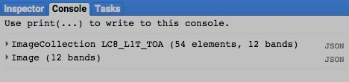 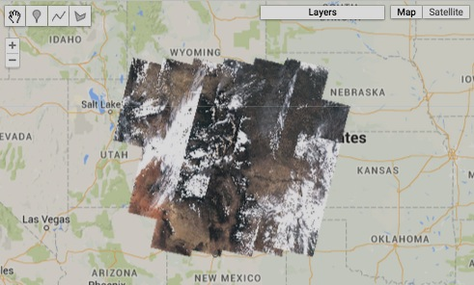

[GOOGLE EARTH ENGINE](EE01%20Earth%20Engine%20(EE).docx) [APPLICATION PROGRAMMING INTERFACE](EE05%20%20%20The%20EE%20API.docx) [CAPABILITIES](EE07%20%20%20%20%20%20API%20Capabilities.docx)

PROCESSING **GENERAL** SATELLITE IMAGERY [VARIABLES](EE13%20%20%20%20%20%20%20%20%20Variables.docx) BY MANAGING **CLOUDS AND SHADOWS**

ee.Algorithms.FMask.matchClouds creates a new image with a single band called ‘csm’ that depicts cloud and shadow masks as computed by

applying the *Fmask* algorithm to a specified image using other specified images that depict potential clouds,

potential shadows, and [brightness temperature](http://www.remss.com/measurements/brightness-temperature); as well as coefficients indicating the upper and lower extents of brightness temperature.

newImage = ee.Algorithms.Fmask.matchClouds

( oldImage, cloudImage, shadowImage, brightnessImage, howDark, howBright, *tilePadding* )

The specified image

The specified image of brightness

temperatures, given in degrees Celsius

The specified

upper limit

(82.5 percentile)

on brightness

temperature

The specified

lower limit

(17.5th percentile)

on brightness

temperature

The new image

The specified image of potential shadows,

on which cloudy pixels are set to 1 and

non-cloudy pixels are masked.

The specified image of potential clouds,

on which cloudy pixels are set to 1 and

non-cloudy pixels are masked.

The amount by which tiles should be padded,

given in pixel witdths. Default: 50.

var

ADD EXAMPLE

[GOOGLE EARTH ENGINE](EE01%20Earth%20Engine%20(EE).docx) [APPLICATION PROGRAMMING INTERFACE](EE05%20%20%20The%20EE%20API.docx) [CAPABILITIES](EE07%20%20%20%20%20%20API%20Capabilities.docx)

PROCESSING **GENERAL** SATELLITE IMAGERY [VARIABLES](EE13%20%20%20%20%20%20%20%20%20Variables.docx) BY **CLASSIFYING** IMAGES

image.unmix creates a new image on which each band represents one of a specified set of “endmembers” for a specified multispectral satellite image.

An endmember is the ideal “signature” of band-by-band values for a given land cover class.

newImage = oldImage.unmix( arrayOfEndmembers )

The specified endmembers, given as an array doubles

The specified image

The new image

var MosaickedIMAGE = ee.ImageCollection( 'LT5_L1T' ).filterDate( '2007-06-01','2007-09-30' ).median();

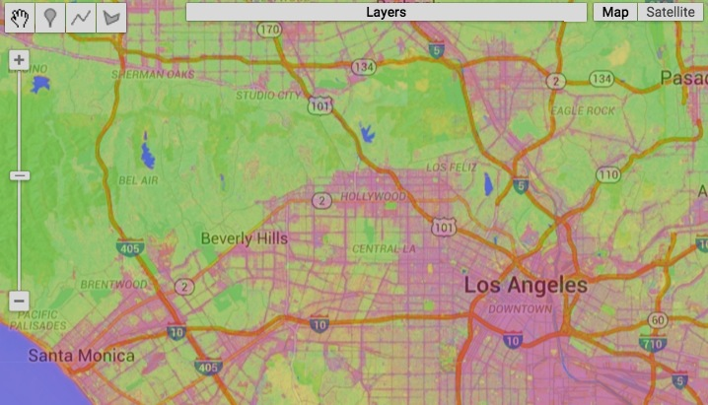var EndmemberARRAY = [ [88.0,42.0,48.0,38.0,86.0,115.0,59.0],

[50.0,21.0,20.0,35.0,50.0,110.0,23.0],

[51.0,20.0,14.0, 9.0, 7.0,116.0, 4.0] ];

var UnmixedIMAGE = MosaickedIMAGE.unmix( EndmemberARRAY );

Map.setCenter(-118.274, 34.0514, 11);

Map.addLayer( MosaickedIMAGE, null, 'Original Image' );

Map.addLayer( UnmixedIMAGE, {min: 0, max: 1}, 'Unmixed Image' );

// Note that the example above is equivalent to the following

var MosaickedIMAGE = ee.ImageCollection( 'LT5_L1T' ).filterDate( '2007-06-01','2007-09-30' ).median();

var ArrayedIMAGE = MosaickedIMAGE.toArray(); //Set each pixel to a 1D array of its 7 band values

var ArrayedIMAGE = ArrayedIMAGE.toArray(1); //Set each pixel to a 2D array of its 7x7 band values

var UrbanARRAY = [88,42,48,38,86,115,59]; //Urban endmember generated by sampling MosaickedIMAGE

var VegetARRAY = [50,21,20,35,50,110,23]; //Veg endmember generated by sampling MosaickedIMAGE

var WaterARRAY = [51,20,14, 9, 7,116, 4]; //Water endmember generated by sampling MosaickedIMAGE

var EndmemberARRAY = ee.Array( [UrbanARRAY, VegetARRAY, WaterARRAY] );

var InverseArrayIMAGE = ee.Image( EndmemberARRAY.matrixPseudoInverse().transpose() );

// Set each pixel to 3x1 array of endmembers fractions ranging from 0 to 1

var UnmixedArrayIMAGE = InverseArrayIMAGE.matrixMultiply( ArrayedIMAGE );

var Unmixed2dIMAGE = UnmixedArrayIMAGE.arrayProject([0]); //Project to axis 0 since axis 1 unnecessary

var Unmixed1dIMAGE = Unmixed2dIMAGE.arrayFlatten([['urban', 'veg', 'water']]); //Flatten to scalar image

Map.setCenter(-118.274, 34.0514, 11);

Map.addLayer( MosaickedIMAGE, null, 'Raw Imagery' );

Map.addLayer( Unmixed1dIMAGE, {min: 0, max: 1}, 'Unmixed (red=urban, green=veg, blue=water)' );

[GOOGLE EARTH ENGINE](EE01%20Earth%20Engine%20(EE).docx) [APPLICATION PROGRAMMING INTERFACE](EE05%20%20%20The%20EE%20API.docx) [CAPABILITIES](EE07%20%20%20%20%20%20API%20Capabilities.docx)

PROCESSING **GENERAL** SATELLITE IMAGERY [VARIABLES](EE13%20%20%20%20%20%20%20%20%20Variables.docx) BY **CLASSIFYING** IMAGES

image.classify creates a new image by replicating a specified image and adding to it a new band of a specified name

whose values are generated by classifying those of the specified image according to a specified classifier.

newImage = oldImage.classify( classifier, newClassificationBandName )

The specified name of the new band, given as a string

The specified classifier

The new image

The specified image, whose band names must be consistent with those called for by **classifier**

var OriginalIMAGE = ee.Image( 'LANDSAT/LC8_L1T_TOA/LC82320672013207LGN00' );

var BandSelectedIMAGE = OriginalIMAGE.select( ['B2','B3','B4','B5','B6','B7','B10','B11'] );

var OriginalFEATURES = ee.FeatureCollection( 'ft:10X7SUjDTiFJDyIA58zLcptK8pwBwjj1BV12SQOgJ' );

var ClassCodedFEATURES = OriginalFEATURES.remap( [1, 2], [0, 1], 'class' );

var BandCodedFEATURES = BandSelectedIMAGE.sampleRegions( ClassCodedFEATURES, ['class'], 30 );

var UntrainedCLASSIFIER = ee.Classifier.cart();

var TrainedCLASSIFIER = UntrainedCLASSIFIER.train(BandCodedFEATURES, 'class', ['B2','B3','B4','B5','B6','B7','B10','B11']);

var ClassifiedIMAGE = BandSelectedIMAGE.classify( TrainedCLASSIFIER );

print( 'Image of All Bands', OriginalIMAGE );

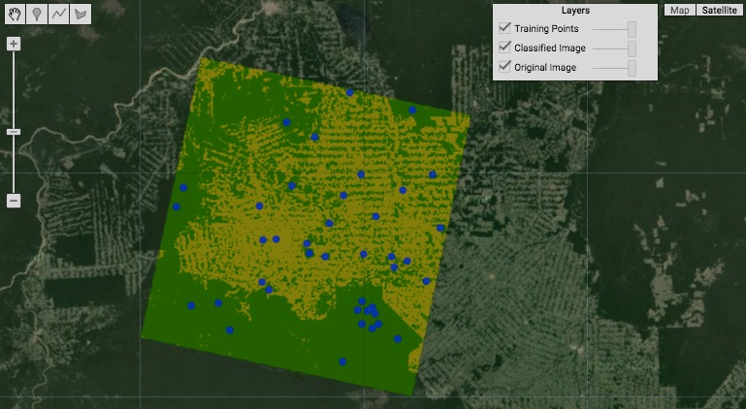print( 'Image of Selected Bands', BandSelectedIMAGE );

print( 'Features by Class', ClassCodedFEATURES );

print( 'Features with Band Properties', BandCodedFEATURES );

print( 'Untrained Classifier', UntrainedCLASSIFIER );

print( 'Trained Classifier', TrainedCLASSIFIER );

Map.centerObject( BandSelectedIMAGE, 8 );

Map.addLayer( OriginalIMAGE,

{bands:['B4','B3','B2'], max: 0.4}, 'Original Image');

Map.addLayer( ClassifiedIMAGE,

{min:0, max:1, palette:['007700', '999900']}, 'Classified Image');

Map.addLayer( ClassCodedFEATURES,

{color:'0000ff'}, 'Training Points' );

[GOOGLE EARTH ENGINE](EE01%20Earth%20Engine%20(EE).docx) [APPLICATION PROGRAMMING INTERFACE](EE05%20%20%20The%20EE%20API.docx) [CAPABILITIES](EE07%20%20%20%20%20%20API%20Capabilities.docx)

PROCESSING **GENERAL** SATELLITE IMAGERY [VARIABLES](EE13%20%20%20%20%20%20%20%20%20Variables.docx) BY CALCULATING **NORMALIZED DIFFERENCE**

image.normalizedDifference creates a new image in which each pixel’s value is set to the difference between its values

on two specified bands of a specified image divided by the sum of those two values.

newImage = oldImage.normalizedDifference( bandNameArray )

The specified bands, given as an array of two string naming the bands. Default: bands 0 and 1

The specified image

The new image

REFINE THIS GOOGLE EXAMPLE

// Compute Normalized Difference Vegetation Index over MOD09GA product.

// NDVI = (NIR - RED) / (NIR + RED), where

// RED is sur_refl_b01, 620-670nm

// NIR is sur_refl_b02, 841-876nm

var img = ee.Image('MOD09GA/MOD09GA_005_2012_03_09');

var ndvi = img.normalizedDifference(['sur_refl_b02', 'sur_refl_b01']);

var palette = ['FFFFFF', 'CE7E45', 'DF923D', 'F1B555', 'FCD163', '99B718',

'74A901', '66A000', '529400', '3E8601', '207401', '056201',

'004C00', '023B01', '012E01', '011D01', '011301'];

Map.setCenter(-94.84497, 39.01918, 8);

Map.addLayer(img.select(['sur_refl_b01', 'sur_refl_b04', 'sur_refl_b03']),

{gain: '0.1, 0.1, 0.1'}, 'MODIS bands 1/4/3');

Map.addLayer(ndvi, {min: 0, max: 1, palette: palette}, 'NDVI');

[GOOGLE EARTH ENGINE](EE01%20Earth%20Engine%20(EE).docx) [APPLICATION PROGRAMMING INTERFACE](EE05%20%20%20The%20EE%20API.docx) [CAPABILITIES](EE07%20%20%20%20%20%20API%20Capabilities.docx)

PROCESSING **MODIS** SATELLITE IMAGERY [VARIABLES](EE13%20%20%20%20%20%20%20%20%20Variables.docx) BY **DECREASING PIXEL SIZE**

ee.Algorithms.SAD.KrigeModis creates a new image by replicating a specified MODIS image at a finer resolution (from 500 to 250 meters)

by using covaiance parameters drawn from a specified feature collection.

newImage = ee.Algorithms.SAD.KrigeModis( oldImage, parameters )

The specified feature collection, given as a geometry with the following columns:

**-** Band (number, 3/4/6/7),

- Model (string, gaussian/spherical/exponential),

- Sill (number),

- Range (number).

For each tile, the first row with an intersecting geometry will be used for each band.

The specified MODIS image

The new image

var

ADD EXAMPLE

[GOOGLE EARTH ENGINE](EE01%20Earth%20Engine%20(EE).docx) [APPLICATION PROGRAMMING INTERFACE](EE05%20%20%20The%20EE%20API.docx) [CAPABILITIES](EE07%20%20%20%20%20%20API%20Capabilities.docx)

PROCESSING **LANDSAT** SATELLITE IMAGERY [VARIABLES](EE13%20%20%20%20%20%20%20%20%20Variables.docx) BY **LIMITING** IMAGE COLLECTIONS

ee.Algorithms.Landsat.pathRowLimit creates a new image collection by replicating a specified Landsat image collection

after limiting it to only the best of a specified number of scenes.

newImageCollection = ee.Algorithms.Landsat.pathRowLimit( oldImageCollection, pathLimit, totalLimit )

The specified Landsat image collection

The maximum number

of scenes scenes per

path. Default: 25

The maximum number

of scenes scenes in

total. Default: 100

The new image collection

var

ADD EXAMPLE

[GOOGLE EARTH ENGINE](EE01%20Earth%20Engine%20(EE).docx) [APPLICATION PROGRAMMING INTERFACE](EE05%20%20%20The%20EE%20API.docx) [CAPABILITIES](EE07%20%20%20%20%20%20API%20Capabilities.docx)

PROCESSING **LANDSAT** SATELLITE IMAGERY [VARIABLES](EE13%20%20%20%20%20%20%20%20%20Variables.docx) BY **REFORMATTING** METADATA

ee.Algorithms.Landsat.translateMetadata creates a new image by replicating a specified Landsat image

after reconfiguring its metadata to the most recent format.

newImage = ee.Algorithms.Landsat.translateMetadata( oldImage )

The specified Landsat image

The new image

var

ADD EXAMPLE

[GOOGLE EARTH ENGINE](EE01%20Earth%20Engine%20(EE).docx) [APPLICATION PROGRAMMING INTERFACE](EE05%20%20%20The%20EE%20API.docx) [CAPABILITIES](EE07%20%20%20%20%20%20API%20Capabilities.docx)

PROCESSING **LANDSAT** SATELLITE IMAGERY [VARIABLES](EE13%20%20%20%20%20%20%20%20%20Variables.docx) BY **CALIBRATING** IMAGES

ee.Algorithms.Landsat.TOA creates a new image by replicating a specified Landsat 4, 5, 7, or 8 image after recalibrating

after recalibrating its top-of-atmosphere (TOA) reflectance and brightness temperature values.

newImage = ee.Algorithms.Landsat.TOA( oldImage )

The specified Landsat image

The new image

REFINE THIS GOOGLE EXAMPLE

// Compare MSS images from L1 through L5

var sfPoint = ee.Geometry.Point(-122.223, 37.892);

Map.setCenter(-122.223, 37.892, 10);

for (var i = 1; i <= 5; ++i) {

var collection = ee.ImageCollection('LM' + i + '_L1T');

var image = ee.Image(collection.filterBounds(sfPoint).first());

var toa = ee.Algorithms.Landsat.TOA(image);

var date = ee.Date(image.get('system:time_start')).format('MMM yyyy');

var bands = (i <= 3) ? ['B6', 'B5', 'B4'] : ['B3', 'B2', 'B1'];

// This is one of the rare places where we need to use getInfo() in the

// middle of a script, since layer names must be client-side strings.

var label = 'Landsat' + i + ' (' + date.getInfo() + ')';

Map.addLayer(toa, {bands: bands, min: 0, max: 0.4}, label);

}

[GOOGLE EARTH ENGINE](EE01%20Earth%20Engine%20(EE).docx) [APPLICATION PROGRAMMING INTERFACE](EE05%20%20%20The%20EE%20API.docx) [CAPABILITIES](EE07%20%20%20%20%20%20API%20Capabilities.docx)

PROCESSING **LANDSAT** SATELLITE IMAGERY [VARIABLES](EE13%20%20%20%20%20%20%20%20%20Variables.docx) BY **CALIBRATING** IMAGES

ee.Algorithms.Landsat.calibratedRadiance creates a new image by replicating a specified Landsat image after recalibrating each of

its bands according to the ‘calibration_gain’ and ‘calibration_gain’ properties of that band.

newImage = ee.Algorithms.Landsat.calibratedRadiance( oldImage )

The specified Landsat image

The new image

var

ADD EXAMPLE

[GOOGLE EARTH ENGINE](EE01%20Earth%20Engine%20(EE).docx) [APPLICATION PROGRAMMING INTERFACE](EE05%20%20%20The%20EE%20API.docx) [CAPABILITIES](EE07%20%20%20%20%20%20API%20Capabilities.docx)

PROCESSING **LANDSAT** SATELLITE IMAGERY [VARIABLES](EE13%20%20%20%20%20%20%20%20%20Variables.docx) BY MANAGING **CLOUDS AND SHADOWS**

ee.Algorithms.Landsat.simpleCloudScore creates a new image by replicating a specified Landsat image after adding to it a band on which

each pixel is set to a value raning from 0 through 100 to indicate to indicate the percent likelihood

that the pixel is part of a cloud.

newImage = ee.Algorithms.Landsat.simpleCloudScore( oldImage )

The specified Landsat image

The new image

var TheALGORITHM = function ( TypicalIMAGE )

{var TheIMAGE = TypicalIMAGE.select( ['B2','B3','B4','B5','B6','B7','B10','B11'] );

var OldScore = ee.Algorithms.Landsat.simpleCloudScore( TheIMAGE );

var NewScore = ee.Image( 1 ).subtract( OldScore ).select( [0], ['cloudscore'] );

return TypicalIMAGE.addBands( NewScore );

};

var OldIMAGES = ee.ImageCollection('LC8_L1T_TOA').filterDate('2013-05-01', '2013-06-01');

var NewIMAGES = OldIMAGES.map( TheALGORITHM );

var NewIMAGE = NewIMAGES.qualityMosaic('cloudscore');

Map.setCenter(-120.24487, 37.52280, 9);

Map.addLayer( OldIMAGES, {'bands':['B4','B3','B2'], 'max':0.4, 'gamma':1.6}, 'Original Image Collection' );

Map.addLayer( NewIMAGE, {'bands':['B4','B3','B2'], 'max':0.4, 'gamma':1.6}, 'Less Cloudy Mosaicked Image');

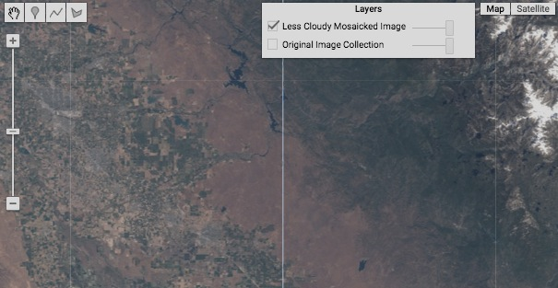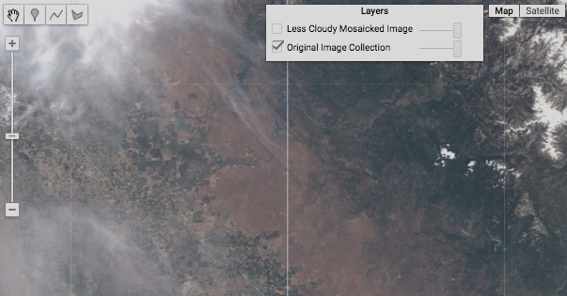

[GOOGLE EARTH ENGINE](EE01%20Earth%20Engine%20(EE).docx) [APPLICATION PROGRAMMING INTERFACE](EE05%20%20%20The%20EE%20API.docx) [CAPABILITIES](EE07%20%20%20%20%20%20API%20Capabilities.docx)

PROCESSING **LANDSAT** SATELLITE IMAGERY [VARIABLES](EE13%20%20%20%20%20%20%20%20%20Variables.docx) BY MANAGING **CLOUDS AND SHADOWS**

ee.Algorithms.Landsat.simpleComposite creates a new image by replicating a specified Landsat image collection after recalibrating its scenes,

computing cloud scores, and limiting it to the least cloudy scenes as defined by specified parameters.

newImage = ee.Algorithms.Landsat.simpleComposite

( oldImageCollection*, percentileLimit, cloudScoreRangeLimit, scenesLimit, floatingPoint?* )

A Boolean set to true (only)

if output is to employ the same

units as Landsat.TOA operation.

Otherwise, they are integers.

Default: false

The maximum acceptable

range of cloud scores per

pixel, given as an integer.

Default: 10

The specified Landsat image collection

The new image

The percentile limit on acceptable cloud scores, given as an integer. Default: 50

The (approximate) limit on how many scenes are to be considered for any one pixel, given as an integer. Default: 40

var OldIMAGES = ee.ImageCollection('LANDSAT/LC8_L1T').filterDate('2015-1-1', '2015-5-1');

var NewIMAGE = ee.Algorithms.Landsat.simpleComposite( OldIMAGES, 50, 10, 40, true );

Map.setCenter( -66.4261, 18.2505, 9 );

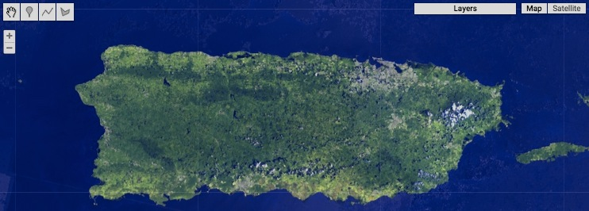Map.addLayer( NewIMAGE, {bands: 'B7,B6,B1', max: [0.3, 0.4, 0.3]});

[GOOGLE EARTH ENGINE](EE01%20Earth%20Engine%20(EE).docx) [APPLICATION PROGRAMMING INTERFACE](EE05%20%20%20The%20EE%20API.docx) [CAPABILITIES](EE07%20%20%20%20%20%20API%20Capabilities.docx)

PROCESSING **LANDSAT** SATELLITE IMAGERY [VARIABLES](EE13%20%20%20%20%20%20%20%20%20Variables.docx) BY CALCULATING **REFLECTANCE**

ee.Algorithms.Landsat.surfaceReflectance creates a new image in which each pixel is set to a value of from 0 through 10000 to indicate

its surface reflectance on a specified Landsat image as calculated by the LEDAPS method.

newImage = ee.Algorithms.Landsat.surfaceReflectance( oldImage, LEPAPSImage, …

A LEDAPS information scene

The specified iLandsat mage

The new image

… surfaceWvImages, seaLevelPressureImages, surfaceTempImages, ozoneImage, elevationImage)

Four NCEP_RE surface wv images for the day of the scene, given as a

list of name strings.

Four NCEP_RE

sea-level pressure images for the day of the scene, given as a list of name strings.

Four NCEP_RE surface temperature images for the day of the scene, given as a list of name strings.

A (TOMS)

ozone image.

A topographic

elevation image.

REFINE THIS GOOGLE EXAMPLE

var scene = ee.Image('LE7_L1T/LE70230391999217GNC00');

// The LEDAPS precomputed image products for our scene of interest.

var precomputed = ee.Image('LEDAPS/L7_PRE/LE70230391999217GNC00');

// Ancillary data.

var surfaceWv = [ee.Image('NCEP_RE/surface_wv/pr_wtr_eatm_1999080500'),

ee.Image('NCEP_RE/surface_wv/pr_wtr_eatm_1999080506'),

ee.Image('NCEP_RE/surface_wv/pr_wtr_eatm_1999080512'),

ee.Image('NCEP_RE/surface_wv/pr_wtr_eatm_1999080518')];

var pressure = [ee.Image('NCEP_RE/sea_level_pressure/slp_1999080500'),

ee.Image('NCEP_RE/sea_level_pressure/slp_1999080506'),

ee.Image('NCEP_RE/sea_level_pressure/slp_1999080512'),

ee.Image('NCEP_RE/sea_level_pressure/slp_1999080518')];

var surfaceTemp = [ee.Image('NCEP_RE/surface_temp/air_sig995_1999080500'),

ee.Image('NCEP_RE/surface_temp/air_sig995_1999080506'),

ee.Image('NCEP_RE/surface_temp/air_sig995_1999080512'),

ee.Image('NCEP_RE/surface_temp/air_sig995_1999080518')];

var ozone = ee.Image('TOMS/MERGED/L3_ozone_epc_19990805');

var dem = ee.Image('srtm90_v4');

// Compute the Surface Reflectance result using default auxilary data.

var ee_sr = ee.Algorithms.Landsat.surfaceReflectance(

scene,

precomputed,

surfaceWv,

pressure,

surfaceTemp,

ozone,

dem);

Map.setCenter(-90.7945, 30.0958, 11);

// Surface reflectance is a unitless ratio scaled to the range 0-10000

// and typically less than 2000.

Map.addLayer(ee_sr, {min: 0, max: 2000}, 'EE Surface Reflectance');

// The "QA" band has various flags encoded in different bits. We extract

// some of them as individual mask bands.

// QA Bit 2: Invalid pixel indicator.

// QA Bit 3: Cloud indicator.

// QA Bit 5: Water indicator. (0 == water).

// QA Bit 6: Pixel used as "dense dark vegetation"

var invalid = ee_sr.select('QA').bitwiseAnd(2).neq(0);

invalid = invalid.mask(invalid);

var cloud = ee_sr.select('QA').bitwiseAnd(4).neq(0);

cloud = cloud.mask(cloud);

// This flag is technically a "not water" flag, so we check for it

// being unset (eq(0)) instead of set (neq(0)).

var water = ee_sr.select('QA').bitwiseAnd(32).eq(0);

water = water.mask(water);

var dense_dark_vegetation = ee_sr.select('QA').bitwiseAnd(64).neq(0);

dense_dark_vegetation = dense_dark_vegetation.mask(dense_dark_vegetation);

// Show various bits from the QA Mask Band.

Map.addLayer(invalid, {palette: '000000,ff0000'}, 'Invalid');

Map.addLayer(cloud, {palette: '000000,ffffff'}, 'Cloud');

Map.addLayer(water, {palette: '000000,0000ff'}, 'Not Land');

Map.addLayer(dense_dark_vegetation, {palette: '000000,00ff00'},

'Dense Dark Vegetation');